CONTENTS

Table Of Content……………………………………………………………………………2
Introduction………………………………………………………………………………....4
Literature Review…………………………………………………………………………...5
Methodology & Dashboard Design…………………………………………………………7
Data preparation and Transformation…………………………………………………7
Dashboard Design and Development…………………………………………………. .9
Dashboard Layout and Wireframe …………………………………………………… 10
Data Analytics Tool Justification……………………………………………………… 14

Discussion…………….……………………………………………………………………….15
Evaluation of the Visualization Solution…………………………………………………15
Key insights and Impact on Decision-Making……………………………………….…15
Actionable recommendations……………………………………………………………..16
Reflection on the effectiveness of Power BI………….……………………………..……17
Conclusion…………………………………………………………………………………….18
References……………………………………………………………………………………..19

INTRODUCTION

In today's healthcare system, hospitals have a harder time finding the right balance between running efficiently, giving patients good treatment, and making money. Hospital managers and clinical personnel need to develop ways to transform the huge amounts of data they get every day into useful information. This data includes patient demographics, admission records, treatment outcomes, and billing information. Sadly, a lot of this data is still separate from each other, captured inconsistently, or not used enough, which makes it hard for departments to make decisions based on data in real time.
The process of understanding the full picture of a patient's data from admission to discharge can be difficult for hospitals. This is due to the fact that their data is dispersed over disparate systems, which makes it challenging to monitor treatment results or effectively manage money. This lack of integration leads to a lot of difficulties. Because of this, important things like room availability, discharge planning, and cost reduction are slowed down, blocked, or missing information that makes it harder to make decisions than it must be.
The goal of this project is to employ data analysis and interactive visualization to find trends and problems in patient admissions, billing performance, and treatment results. Business Intelligence (BI) tools like Power BI will change and show hospital data in easy-to-understand dashboards. This data can include things like patient age, gender, diagnosis, admission and discharge dates, medications, test results, doctor assignments, and billing information. These visuals can help identify trends in patient flow, highlight frequent or costly medical conditions, monitor physician workloads, and highlight variations in insurance and billing performance.
This project will provide useful information that helps with important administrative goals by using trend analysis, client (patient) segmentation, and even forecasting tools.
• Making billing cycles and insurance processing work better.
• Cutting down on how long patients have to wait and how long they have to remain.
• Keeping an eye on and managing the workloads of doctors and departments.
• Finding medical conditions that are expensive or happen often.
Business Intelligence and data visualization are very important to this process because they turn complicated information into interactive, real-time insights that decision-makers can easily study and comprehend. Cleaning, organizing, and combining data from many sources is another way to make these visualizations both accurate and useful. The ultimate aim of this initiative is to boost operational efficiency, raise the standard of patient care, and help hospitals stay financially stable by using better, data-driven tactics.

LITERATURE REVIEW

The growing complexity of modern healthcare systems has led to a lot of interest in using data analytics and Business Intelligence (BI) to improve clinical and operational decision-making. Hospitals currently create a lot of data every day, such as electronic health records (EHRs), lab findings, billing statements, and insurance claims. However, a lot of this data is either walled or not used enough (Raghupathi & Raghupathi, 2014). This spread makes it hard to keep track of money, organize patient care, and employ resources well.
Studies demonstrate that BI systems may rectify these shortcomings by integrating various data sources and presenting them through interactive dashboards and visualizations (Wang et al., 2018). Power BI and Tableau are two examples of business intelligence (BI) systems that have grown popular in the healthcare profession because they can conduct descriptive, diagnostic, and predictive analytics (Kankanhalli et al., 2016). These tools let hospital administration observe patterns in patient admissions, keep an eye on how effectively therapies are working, and figure out how well the hospital is doing financially almost in real time (Davenport & Harris, 2007).
A rising number of scholarly papers show that data visualization may help make better clinical and administrative decisions. Few (2009), for example, says that well-designed dashboards help people understand things quickly and make better judgments, especially in high-stress places like hospitals. Kohli and Tan (2016) further say that data-driven healthcare systems lead to improved patient outcomes and lower costs because they provide stakeholders with the opportunity to act on insights from both historical and real-time data.
Trend analysis and segmentation methods are especially useful for managing hospitals. Belle et al. (2015) say that looking at trends in patient demographics, admission rates, and duration of stay can help find systemic problems and help with staffing, bed allocation, and discharge planning. Segmentation based on age, severity of ailment, or kind of insurance, on the other hand, enables focused treatments and tailored care pathways, which improves both clinical results and operational throughput (Mehta & Pandit, 2018).
Even with these benefits, there are still problems. A lot of hospitals don't have the right infrastructure or data governance rules to enable strong BI projects (Sharma et al., 2016). Also, if you don't use the right data transformation techniques, visualizations won't be accurate or reliable because of inconsistent data entry, missing values, and unstructured formats (Inmon et al., 2010). Cleaning, normalizing, and adding data are all important steps to make sure that insights are useful and relevant.
Some of the best healthcare providers in the business are already embracing BI to improve their performance. For instance, Mayo Clinic and Kaiser Permanente have set up data dashboards to keep an eye on patient flow, cut down on wait times, and boost staff efficiency (Healthcare Information and Management Systems Society [HIMSS], 2020). These stories show how important it is to turn raw data into intelligence that can be used to make decisions.
In conclusion, there is a lot of evidence that using BI and data visualization together in hospitals may make them more efficient, save them money, and provide patients better treatment. But for these kinds of projects to work, they need to be carefully planned and carried out with strict data transformation. This project uses current BI technologies to look at hospital data and solve important administrative problems including billing optimization, resource allocation, and treatment efficacy.

METHODOLOGY

This project uses Power BI to explore and visualize hospital data in an iterative, data-driven way. The subsections explain how to prepare and change the data, design and build the dashboard, layout and wireframe the dashboard, and justify the use of a data analytics tool to give a meaningful picture of the chosen dataset.
Data preparation and Transformation
The information in this report comes from Kaggle. We chose the Hospital dataset because it has a lot of different types of variables, both numerical and categorical. It has information on the hospital's patients, medical information, billing information, admission details, and physicians. This kind of dataset contains information like the patient's name, age, gender, blood type, medical condition, date of admission and discharge, names of doctors, insurance providers, billing amount, kind of admission, medication and test results, and any other information that is important.
Before the dashboards can be made using the greatest visualization approaches, the raw data must go through a number of data processing steps. These steps are:
Data cleaning: Python was used to clean the dataset by removing duplicate entries in the Names of patient, blank and strange Medical Conditions, Test Results, and Medications, and missing values in the date of admission column.
Data Preparation: The data was brought into Power BI, and then category fields were made to make the Conceptual Model (Fig. 1) from the primary table to demonstrate how the data is related.
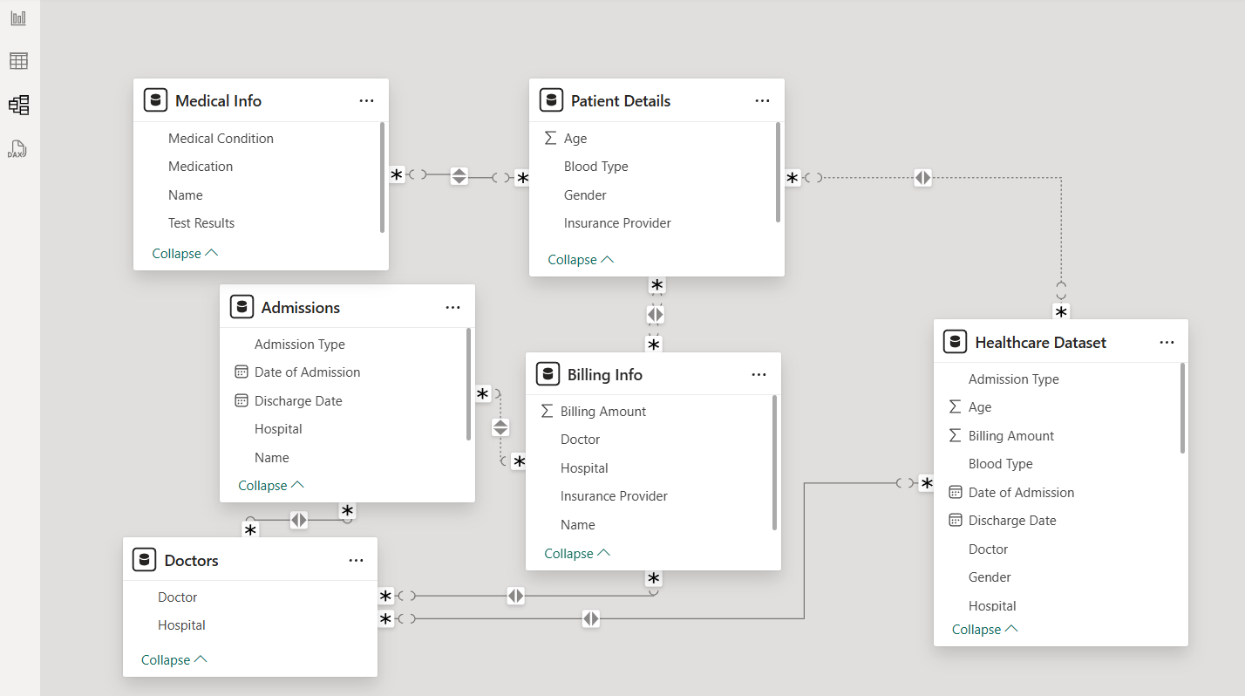
Fig.1 Conceptual Model: Hospital Management System
Data Analysis: This part focused on the statistics part where DAX was used to create a series of new measures of total number of patients, average billing amount, total number of doctors, diagnosis count, doctor workload and a new column was also created to sum the number of days spent in the hospital by each patient.

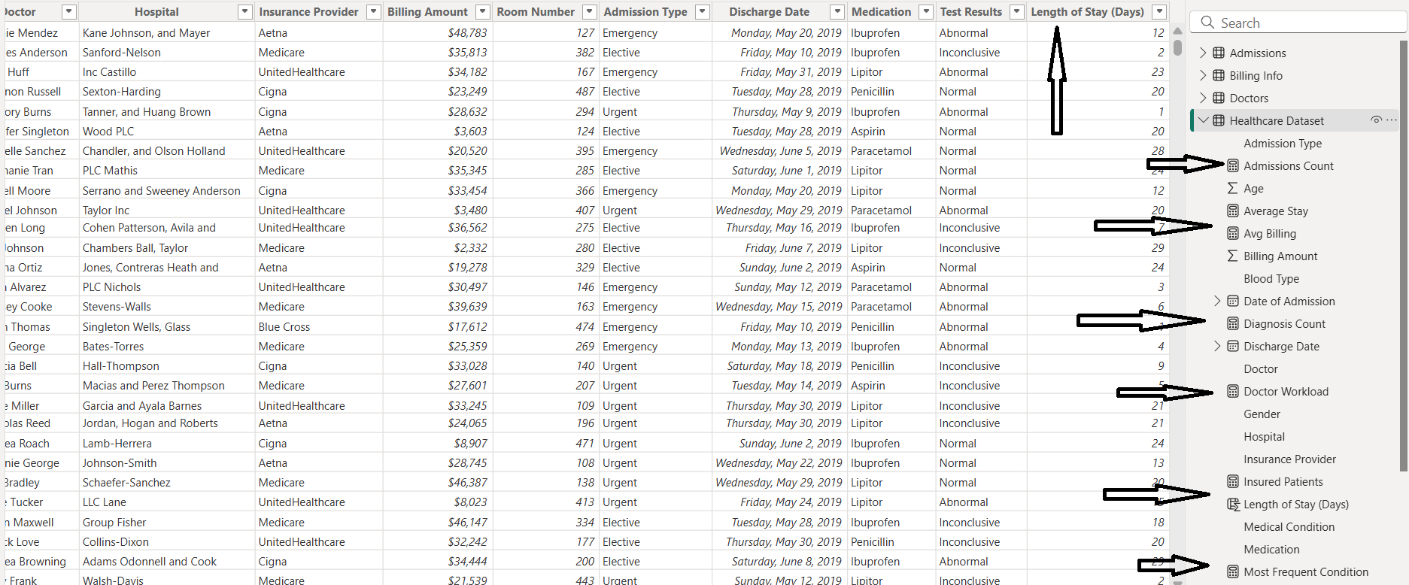
Fig.2 DAX: Calculations for Defined Role

Dashboard Design and Development
To build each visual using particular technique and overview topics was defined with the purpose of further understanding the hospital’s overall performance. A series of trials and errors were encountered as part of the selection process to successfully create 4 separate dashboards Hospital performance overview, Patient admission & discharge insights, medical conditions and treatment overview, financial analysis and insurance insights and hospital and doctor performance. The following visualizations elements are selected based on their ability to effectively communicate specific insights in created dashboards:

Visualization Type | Use Case | Pros | Cons
Line Chart | Trends over time (monthly admissions, billing) | Good for showing patterns and changes over time | It can be hard to read with too many lines or overlapping values
Bar/Column Chart | Comparing categories (billing by condition, doctor workload) | Simple, direct, and effective for comparisons | Not suitable for very large category sets
Stacked Bar Chart | Billing per insurance provider by condition | Shows distribution within a category | Can become cluttered with too many stacked elements
Pie/Donut Chart | Proportion of patient types, gender, or insurance usage | Good for showing parts of a whole of something | Less accurate for detailed comparison; not ideal for many slices
Matrix/Table | Detailed view of multiple KPIs by patient or doctor | Provides detailed, readable data in tabular format | Not visually appealing; better for drill-downs
Card (KPI Visual) | Key metrics (Total patients, Average stay(days), and Average Billing) | Highlights critical KPIs immediately | Offers limited context unless paired with other visuals
Table 1: Visualization Techniques Selection and Justification
Dashboard Layout and Wireframe
The dashboard is easy to read, interactive, and clear for executives. Fig. 3 is a schematic layout of the hospital performance overview. It shows the KPI card with information about the total number of patients (25,000), the average billing ($26k), and the average stay (15.51 days), which is in the lower right corner. Out of the total number of patients, 11,000 were recorded as females as shown on the donut chart. 4.4k patients were diagnosed with Arthritis as the highest medical condition while the lowest out of the 6 was Asthma with 3.9k diagnosed patients. Lastly the line chart shows the trend of patients admitted in months with March and August recording highest 2205 and 2218 patients respectively. The additional type records show an almost equal number of patients between 8510- 8128 in all 3 types (Elective, Emergency & Urgent).
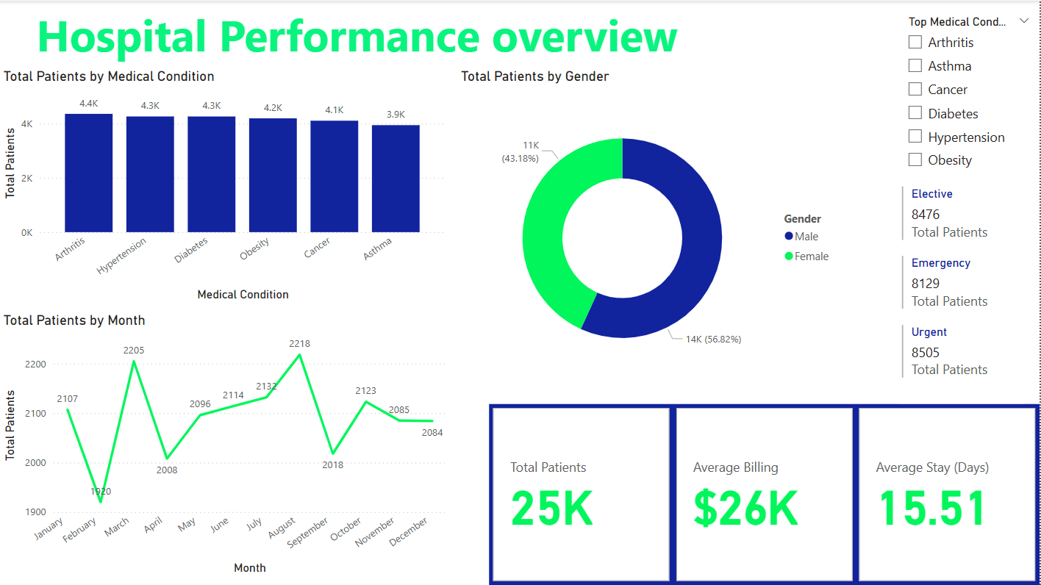
Fig 3: hospital performance overview
Patient admission shows in (Fig 4) monthly admission broken down by admission type with each month averages about 2,000 admissions. The bar chart further shows distribution is fairly consistent across the month with Urgent admission slightly dominating most months. The gauge indicates that patient stays range from 0 to 31.03 days with the average slightly below the midpoint. The link chart shows the trend of discharge from 2019 to 2024. Peak in 2020 (5.2k discharges), with steady rate (5k/year) until notable drop in 2024(1.7k), likely due to partial year data. The discharge test results are relatively evenly distributed with abnormal discharge highest.
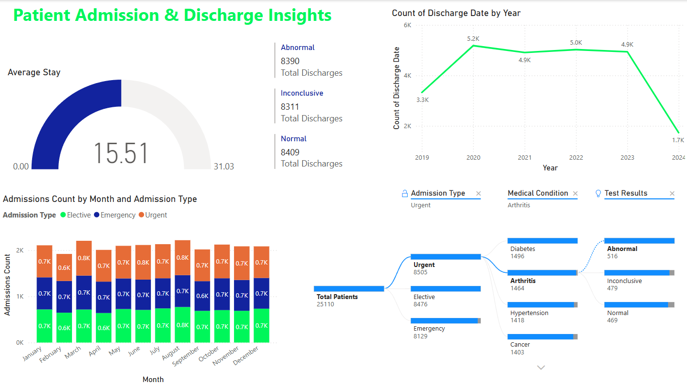
Fig 4: patient admission & discharge insights
There is a clear difference between the sum male to female patients even in medical conditions males’ patients between 2.4K to 2.3k while female’s patients 2.0k to 1.5k as shown on the clustered column chat in (fig 5). Both genders recorded highest medical conditions 2.4 & 2.0 male and female patients making Arthritis most frequently condition with total billing of $112M as shown in the stacked area chart the remaining billing by medical conditions range between $110M - $102M. The medical test results for admission count values were relatively evenly distributed. However, patient diagnosed with Arthritis the total test result was recorded as abnormal.
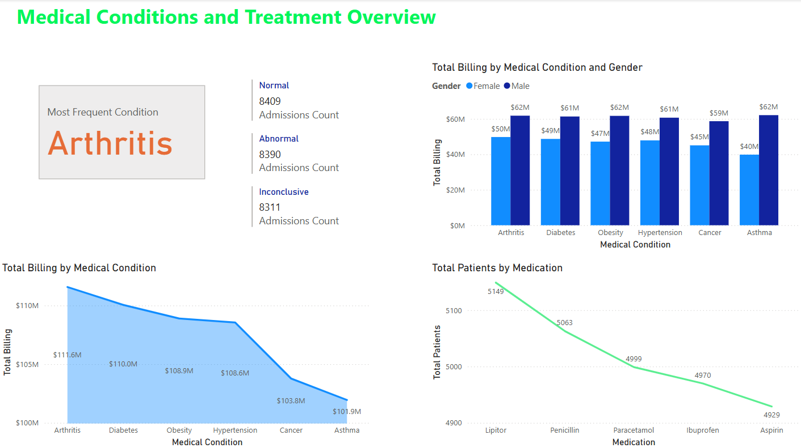
Fig 5: Medical condition and treatment overview
The bar charts in (fig 6) shows Billing is fairly consistent across between $0.22M-$0.29M and top performing doctors, with slight lead by John Smith $ 0.35M. The scattered plot shows a positive correlation with longer hospital stays and leads to higher billing. The total insurance billing $5.08M with UnitedHealthcare and Medicare covering the largest share of payments as shown in the matrix. Align with the billing trend the peak for total billing was 2020 with $132M then stable between 2021-2023 with $128M and significant drops in 2024 $45M due to incomplete data.
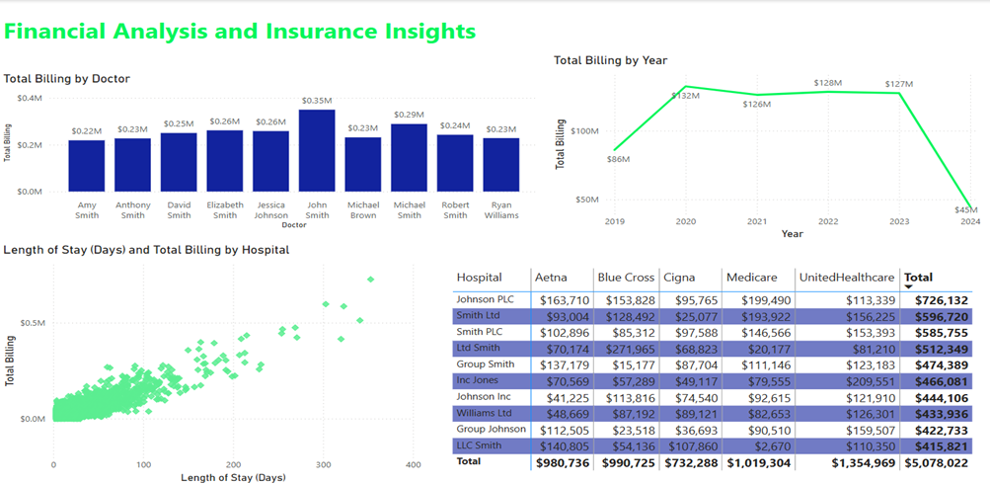
Fig 6: Financial analysis and Insurance Insights
The top hospitals by patient volume, Willian’s Ltd (23 patients) came first, the remaining top hospital range between 14-21 patients each, Indicating relatively balanced workloads among leading institutions. This also relates to the doctor’s workloads with efficient distribution of cases as seen on bar charts in (Fig 7). Billing values are tightly clustered with very little differences. This indicates that the best doctors all charge the same way. The overall trend shows stable discharge activity across the year.
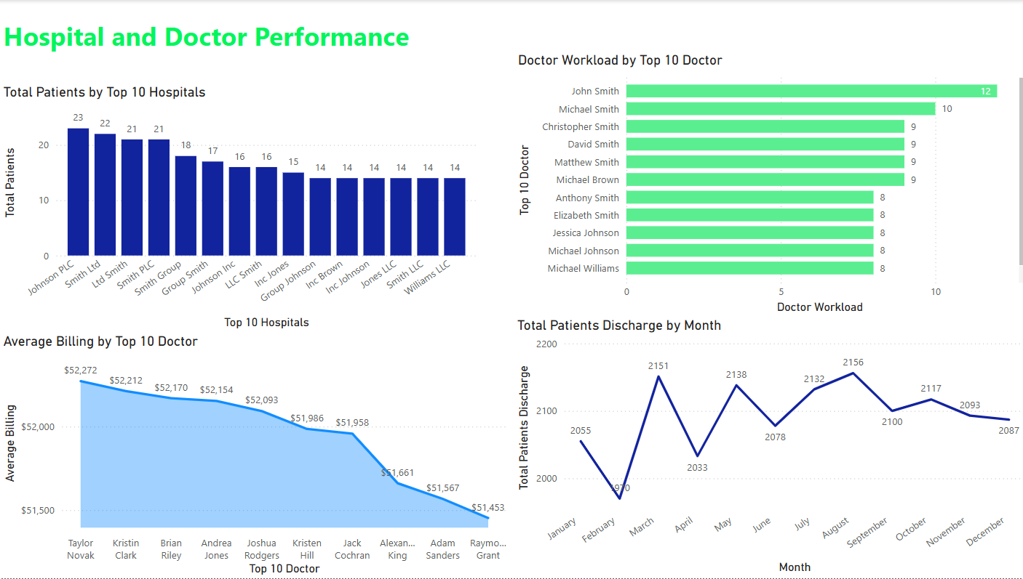
Fig 7: hospital and doctor performance
Data Analytics Tool Justification
Power BI was chosen because it works well with Microsoft Office products, which makes it easier for people who currently use Excel. It has a user-friendly drag-and-drop interface that makes it easy to design dashboards quickly, it works well with Excel, and it enables real-time filters, drill-downs, and user-driven queries. it Cost-effective for most healthcare institutions while offering role-based access and compliance features Power BI Service.

DISCUSSION

Evaluation of the Visualization Solution
The Power Bi dashboard that was put in place effectively combines hospital data from several tables in a number of ways, such as patient demographics, medical conditions, billing, insurance, admissions, discharges, and provider performance. The dashboard is designed to be clear and easy to use for CEOs and those who make health care decisions. Key metrics such as total patients, average billing, length of stay, and insurance coverage are visualized to support operational oversight and strategic planning. The visualization project finds trends, bottlenecks, and patterns that are usually concealed in systems that store raw data. The dashboard shows good data storytelling overall, which lets those who aren't tech-savvy rapidly get useful information.

Key insights and Impact on Decision-Making
Key Insights:
- High Patient Volume: The hospital treated over 25,000 patients, with female patients representing 44% (11,000).
- Common Conditions: Arthritis is the most frequently diagnosed condition, with 4.4k cases and $112M in billing.
- Balanced Admission Types: Elective, emergency, and urgent admissions are nearly equal, each around 8.1k–8.5k.
- Discharge Trends: A noticeable peak in discharges in 2020, followed by stability and a decline in 2024 (likely due to incomplete data).
- Gender Disparity: There are always more men than women with medical conditions.
- Billing Correlation: The longer a person remains in the hospital, the more they will have to pay.
- Insurance Impact: UnitedHealthcare and Medicare account for the bulk of insurance payments ($5.08M total).
- Doctor Performance: Billing is consistent across doctors, with John Smith leading slightly. Hospital workloads are evenly distributed.
Impact on Decision-Making:
- Resource Allocation: Balanced admission types suggest the need for consistent staffing and facility availability across all categories.
- Clinical Prioritization: Arthritis requires special attention due to its high frequency and cost implications.
- Gender Health Strategies: Addressing differences in gender-based diagnoses could guide outreach and treatment strategies.
- Financial Planning: The insurance matrix supports forecasting of future billing cycles and insurer negotiations.
- Operational Strategy: Discharge and stay duration trends can inform policies to optimize patient flow and improve bed turnover.

Actionable recommendations
- Target High-Cost Conditions: Create plans for managing care and lowering costs that are only for people with arthritis.
- Review Gender-Specific Programs: Investigate on why there are differences in diagnosis across genders and think about using gender-specific health interventions
- Optimize Length of Stay: Look into patient routes and methods to make things more efficient to shorten the average stay without sacrificing care quality.
- Enhance Discharge Efficiency: Monitor discharge congestion and plan for smoother transitions, especially in peak months.
- Monitor Billing Consistency: Maintain standardized billing practices across doctors and departments to ensure transparency and compliance.
- Leverage Insurance Data: Negotiate better terms with top insurers using detailed data on billing contributions and patient volumes.
- Utilize Real-Time Dashboards: utilize Real-Time Dashboards: Get department leaders to utilize live dashboards to keep an eye on daily operations and make decisions.
Reflection on the effectiveness of Power BI
Power BI made it easy bled easy, quick and interactive exploration of complex hospital data. Slicers, DAX formulas, and drill-through are among the features that helped people make better decisions by showing them hidden inefficiencies and trends.

CONCLUSION

Power BI was used to develop the hospital performance dashboard, which provided a comprehensive, data-driven view of critical medical activities. Interactive features and simple visualizations provide key performance factors such patient volume, average billing, length of stay, gender distribution, frequent medical condition, and financial trends linked to insurance provider billing.
Some of the most important results are that arthritis is very common and expensive, that there is a big difference in the number of men and women who are diagnosed with it, that there are a lot of different types of admissions, and that the duration of stay is closely related to the amount billed. The dashboard also displays how discharges have changed over time. They peaked in 2020 and then went down in 2024. This is likely due to incomplete data.
This dashboard helps healthcare managers make strategic decisions by letting them find out what costs are driving up costs, how to use resources more effectively, how to fix gaps in patient care, and how to improve operational performance. The information given gives stakeholders the authority to make smart, evidence-based choices that can improve patient outcomes, make the healthcare institution more efficient, and help it stay financially stable.

REFERENCES

- Belle, A., Thiagarajan, R., Soroushmehr, S. M. R., Navidi, F., Beard, D. A. & Najarian, K. (2015) ‘Big data analytics in healthcare’, BioMed Research International, 2015, pp. 1–16. Available at: https://doi.org/10.1155/2015/370194
- Davenport, T. H. & Harris, J. G. (2007) Competing on analytics: The new science of winning. Boston: Harvard Business School Press. Available at: https://books.google.com/books/about/Competing_on_Analytics.html?id=10q3x5zWZE4C
- Few, S. (2009) Now you see it: Simple visualization techniques for quantitative analysis. Oakland, CA: Analytics Press. Available at: https://www.perceptualedge.com/library.php
- Healthcare Information and Management Systems Society (HIMSS) (2020) ‘Case studies in healthcare analytics adoption’, HIMSS.org. Available at: https://www.himss.org/resources/case-studies-healthcare-analytics
- Inmon, W. H., Strauss, D. & Neushloss, G. (2010) DW 2.0: The architecture for the next generation of data warehousing. Amsterdam: Elsevier. Available at: https://www.elsevier.com/books/dw-2-0/inmon/978-0-12-374319-0
- Kankanhalli, A., Hahn, J. & Tan, S. S.-L. (2016) ‘Business intelligence in healthcare: A study of antecedents and consequences’, Information Systems Frontiers, 18(2), pp. 257–272. Available at: https://doi.org/10.1007/s10796-014-9500-2
- Kohli, R. & Tan, S. S.-L. (2016) ‘Electronic health records: How can IS researchers contribute to transforming healthcare?’, MIS Quarterly, 40(3), pp. 553–573. Available at: https://misq.org/electronic-health-records-how-can-is-researchers-contribute-to-transforming-healthcare.html
- Mehta, N. & Pandit, A. (2018) ‘Concurrence of big data analytics and healthcare: A systematic review’, International Journal of Medical Informatics, 114, pp. 57–65. Available at: https://doi.org/10.1016/j.ijmedinf.2018.03.006
- Raghupathi, W. & Raghupathi, V. (2014) ‘Big data analytics in healthcare: Promise and potential’, Health Information Science and Systems, 2(1), pp. 1–10. Available at: https://doi.org/10.1186/2047-2501-2-3
- Sharma, R., Yetton, P. & Zmud, R. W. (2016) ‘Implementation costs of healthcare information systems: A framework and research agenda’, Information Systems Research, 27(4), pp. 767–783. Available at: https://doi.org/10.1287/isre.2016.0646
- Wang, Y., Kung, L., Wang, W. Y. C. & Cegielski, C. G. (2018) ‘An integrated big data analytics-enabled transformation model: Application to health care’, Information & Management, 55(1), pp. 64–79. Available at: https://doi.org/10.1016/j.im.2017.04.001
- https://www.kaggle.com/datasets/prasad22/healthcare-dataset

